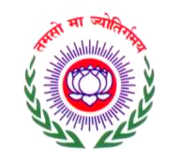
Dr. MCR HUMAN RESOURCE DEVELOPMENT INSTITUTE
GOVERNMENT OF TELANGANA

REGISTRATION FORM

- Program Data
e-Learning Training programme for cutting edge level functionaries of Govt. of Telangana State.
- Title: B). Program No.:

11-08-2017
C) Date : To

- Personal Data

- Name
First or given Name Surname / Last Name

B) Designation:

Date Month Year
M F
C) Gender *

D) Mobile No.:

E) E-mail ID :

F) Residential Status : Yes No

G) Specify the place where you intend to complete the e-Leaning Programme –

H) District :

Date: Signature of the Participant

- Trainings undergone (last 5 years):
Course Title | Institution | Dates

- Preferences :
Physical Training

Art of Living

Yoga

A). Option for fitness activity*:

B). Food preference (if any):

Date: Signature of the Participant
* Please (√) in the appropriate box.

